**INSTALLING PYTHON PACKAGES**

ONCE STARTED VAGRANT SERVER INSIDE OUR PROJECT FOLDER, AND ONCE WE’VE CONNECTED TO SERVER, LET’S ACTIVATE PYTHON VIRTUAL ENVIROMENT:

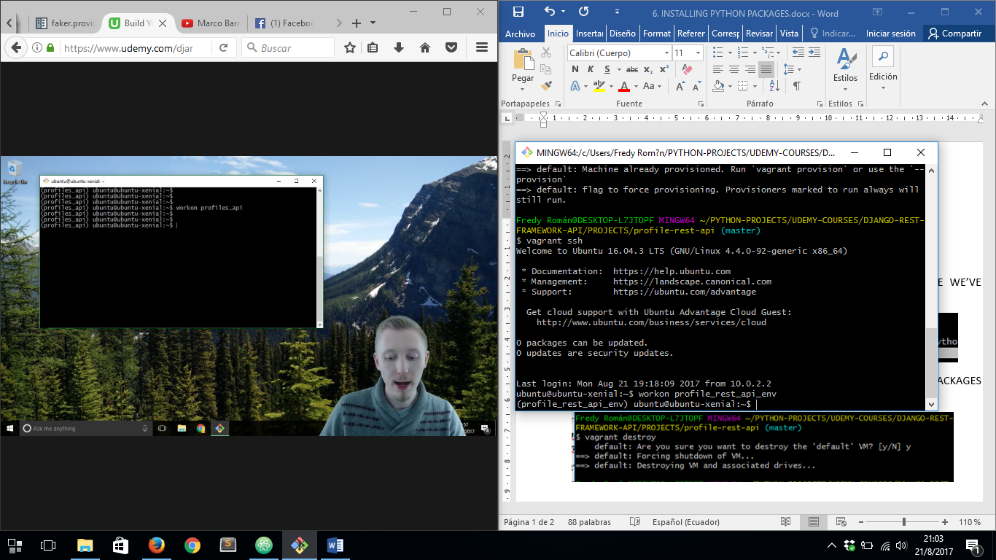

THEN WE ARE GOING TO INSTALLA SOME PACKAGES:

Django 1.11 and Django rest framework 3.6

